

**Supply-414 Regulated Waste Center**

**Compatible with the following RecyclePak® & ReturnPak® products**

**(purchased separately):**

**Supply-098 Small 4FT Fluorescent Lamp Recycling Box**

**Supply-093 1/2 Gal Dry Cell Battery Recycling Pail**

**Supply-339 VSQG 6 Aerosol Can Recycling Box**

**Supply-413 Extra Small Electronics Recycling Box**

**Assembly Instructions**

**Questions regarding this container should be directed to customer service, toll-free at 1-888-669-9725.**

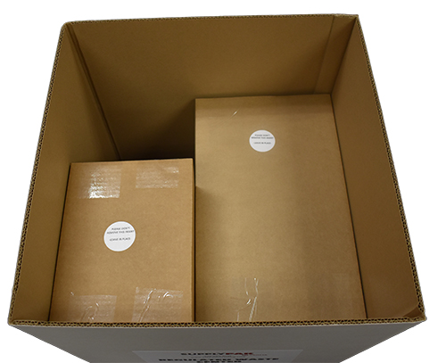

**DO NOT REMOVE**

**Figure 2**

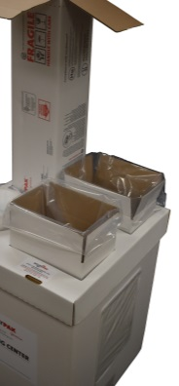

**Figure 4**

**Figure 1**

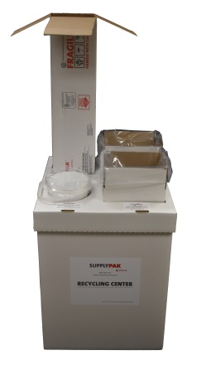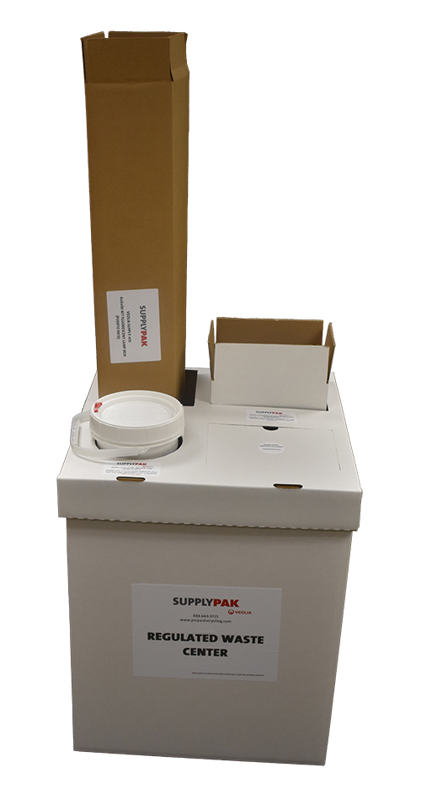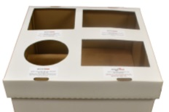

**Figure 3**

**Regulated Waste Center (Applies to Supply-414)**

**Required Safety Supplies:**

Veolia recommends the user of this service to utilize gloves and safety glasses when handling any kind of waste MATERIALS.

**AUTHORIZED CONTENTS: -** The Regulated Waste Center is authorized to hold/store these individual RecyclePak® & ReturnPak® products (Supply-098, Supply-093, Supply-339, and Supply-413) to allow for the ease of sorting recyclable materials **(See Figure 1)**. The Regulated Waste Center itself cannot be filled and returned with items requiring recycling. The Supply-533 Regulated Waste Center is a supply only. The individual RecyclePak® and ReturnPak® products (purchased separately) need to be prepared, filled, sealed and returned for recycling following the instructions included with each product.

**Step #1 – Regulated Waste Center Unpacking**

1. The Regulated Waste Center will arrive pre-assembled. Please **DO NOT REMOVE THE CORRUGATED SUPPORT INSERTS** from the Regulated Waste Center **(See Figure 2)**. The supports are taped in the position they must stay in to support the individual RecyclePak® and ReturnPak® products that will be inserted into the pre-labeled Regulated Waste Center cover slots. Make sure the Regulated Waste Center Cover is placed correctly on the container **(See Figure 3)**.

**Step #2 – Prepare Individual RecyclePak® and ReturnPak® Products (If purchased)**

1. **Assemble each of the individual RecyclePak® and ReturnPak® products following the instructions that are included with each.**
2. Please note that the Supply-093 battery pail return box will need to be stored separately as is or the tape on the bottom flaps of the box can be cut and the box can be folded and tucked in the Regulated Waste Center to store it until it is time to return the filled battery pail.

**Step #3 – Regulated Waste Center Set-up**

1. Place each of the compatible RecyclePak® and ReturnPak® products into their pre-labeled Regulated Waste Center cover slots **(See Figure 1 & Figure 3)**.
2. Place any remaining product components (i.e. zip ties, instructions, etc.) into the reclosable envelope that is attached to the side of the Regulated Waste Center **(See Figure 4)**.
3. When each RecyclePak® and ReturnPak® product is full, follow the saved instructions to prepare the product for return shipping and processing.